Ken Bima Satria Gandasasmita

23/516183/PA/22062

ASSIGNMENT 4 LAB PROGRAMMING

Problem 1.

Create a program to create full of the pyramid using \* symbols (as shown in the screenshot) with the height of the pyramid determined by the user.

Answer =

#include <iostream>

using namespace std;

int main() {

    int n,b;

   cin>>n;

     for (int i = 0; i <= n; i++)

     {

          for (int k = n; k > i; k--)

         {

             cout<<" ";

         } cout<<"";

         for (int j = 1; j <= (2\*i-1); j++)

         {

             cout<<"\*";

         }

         cout<<endl;

Prove=

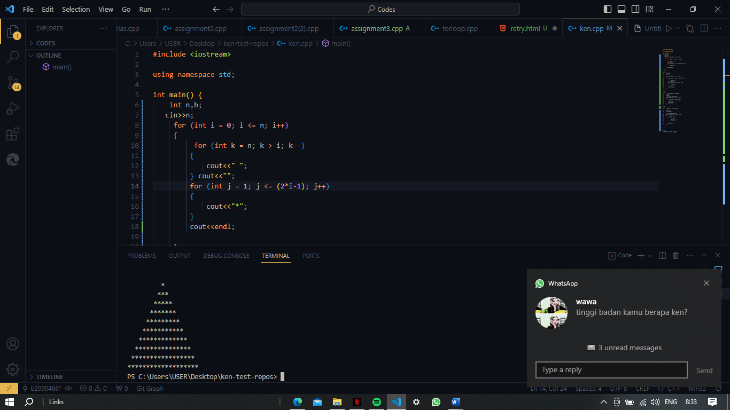

Problem 2.

Create a program to display the multiplication tables as shown in the screenshot 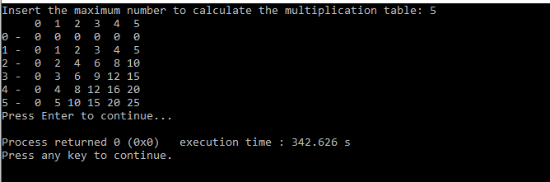

Answer =

#include <iostream>

using namespace std;

int main() {

    int n;

    cin>>n;

    for (int i = 1; i <= n; i++)

    {

       for (int j = 1; j <= n; j++)

       {

        cout<<i\*j<<" ";

        }

        cout<<endl;

       }

    }

Prove =

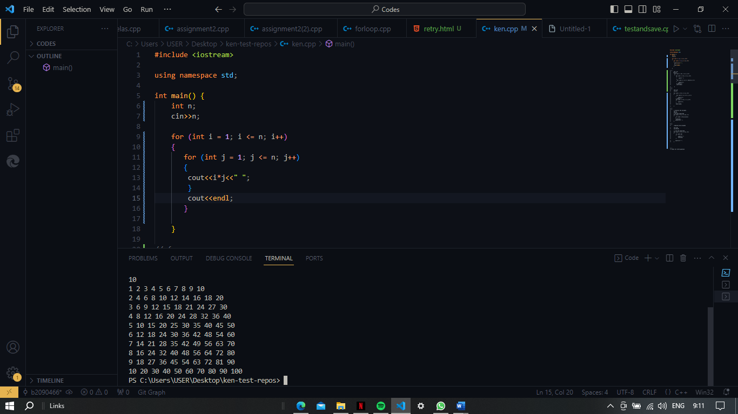

Problem 3.

Create a program to display even numbers whose value is less than or equal to the input number. Then display it from the largest value to zero.

Example:

Input: 7 -> Output: 6 4 2 0

Input: 4 -> output: 4 2 0

Answer =

#include <iostream>

using namespace std;

int main() {

*// declare the variable*

    int n;

    cin>>n;

*// do the algorithm*

    for (int i = n; i >= 0; i--)

    {

        if ((i%2 != 0)||(i==n))

       {

        continue;

       }cout<<i<<" ";

    }

}

Problem 4.

Create a program to generate a pattern according to the following example.





Input: N K

With : 1 ≤ N ≤ 100; 1 ≤ K ≤ N

Answer :

#include <iostream>

using namespace std;

int main() {

*//declare the variable*

    int K,N;

cout<<”enter two integers :”;

    cin>>K>>N;

*// set the algorithm*

    for (int i = 1; i <= K; i++)

    {

        if (i%N ==0)

        {

            cout<<"\* ";

            continue;

        }

       cout<<i<<" ";

    }

Prove=

